Q-3-2
Correct answers marked with an asterisk (*)

1) The following histogram shows the distribution of the difference between the actual and "ideal" weights for 119 female students. Ideal weights are responses to the question "What is your ideal weight"? The difference = actual – ideal.
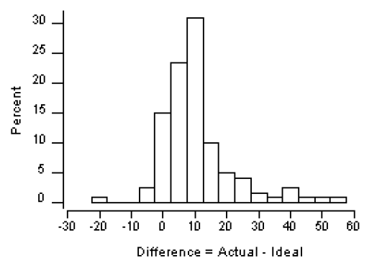
What is the approximate shape of the distribution?
a. Nearly symmetric.
b. Skewed to the left.
*c. Skewed to the right.
d. Bimodal

2) The following histogram shows the distribution of the difference between the actual and "ideal" weights for 119 female students. Ideal weights are responses to the question "What is your ideal weight"? The difference = actual – ideal.
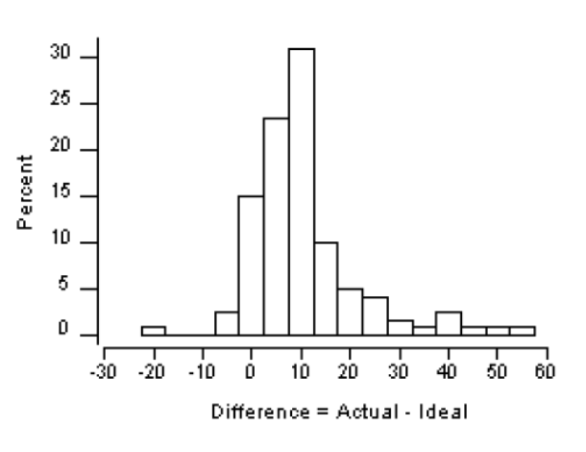
How does the mean compare to the median in this data set?
*a. The mean is larger than the median.
b. The median is larger than the mean.
c. The median and mean are approximately equal.
d. The mean and the median cannot be compared without calculations.

3) The following histogram shows the distribution of the difference between the actual and "ideal" weights for 119 female students. Ideal weights are responses to the question "What is your ideal weight"? The difference = actual – ideal.
If the observation at -20 pounds was removed from the data set, the mean _____.
*a. would increase
b. would decrease
c. would remain the same
d. may or may not change

4) A hot dog manufacturer asserts that a brand of hot dogs has an average fat content of 18 grams per hot dog. Fat contents in hot dogs from this manufacturer follow an approximately normal distribution with a standard deviation of 1.1 grams. Define the statistic x = mean fat content in a random sample of 10 hot dogs.
The value 18 is the _____.
a. sample size
*b. statistic
c. parameter
d. standard deviation

5) A hot dog manufacturer asserts a brand of hot dogs has an average fat content of 18 grams per hot dog. Fat contents in hot dogs from this manufacturer follow an approximately normal distribution with a standard deviation of 1.1 grams. Define the statistic x = mean fat content in a random sample of 10 hot dogs.
Is the sampling distribution of x approximately normal?
a. No, since the sample size is too small for the Central Limit Theorem to hold.
b. No, since the manufacturer does not know if the population of hot dogs is more than 20 times the size of the sample.
*c. Yes, since the population of fat contents in hot dogs is approximately normal.
d. Not enough information exists to determine if the sampling distribution of x is approximately normal.

6) Which of the following distributions would have the smallest standard deviation?
a. Number of miles put on a rental car in one day
b. Average number of miles put on a rental car per day across 5 customers
*c. Average number of miles put on a rental car per day across 25 customers
d. Distributions of all of the above would have the same standard deviation.

